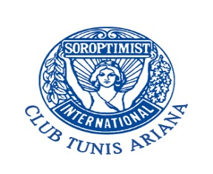10th anniversary - REGISTRATION –
Please register before 30/09/2018 send your form to: si.tunariana@hotmail.com
Personnal Information: First Name:
Last Name :
Email :
Cellular phone:
Soroptimist Club :
1 november 2018 : Arrival of guests - Transfer from the airport
Visit – Culture City Tunis
2 november 2018 : Historical Tour to Dougga (Lunch inclusive)
Friendship dinner & Club presentation
3 november 2018 : Visit *Ksar Warda,*handcraftvillage Denden, *Sidi Bou Said, *Carthage
(Lunch inclusive)
Anniversary dinner
4 november 2018: Visit – Bardo Museum
-----------------------------------------------------------------------------------------------------------------------165 EUR
5 > 8 november 2018: Post tour- South Tunisia
4 days/3 nights 130 EUR ------------------------
TOTAL AMOUNT: =
Payment : Please note that registration will be complete upon payment.
Bank Transfer to: Soroptimist International Club Tunis Ariana
Bank name: Amen Bank
IBAN: TN 59 0705 8011 6105 5011 4954 Code BIC: CFCTTNTT
Notification code: 10th anniversary + name

