Soroptimist at the Historical Carnival

24 August Friday

15:00 Picnic in the Garden of Savaria Museum
Registration
Purchase of Historical Costumes
Programme in the Franciscan Garden

19:00 Watching/Participating in the
Procession of the Costume Parade

25 August Saturday

14:00 Visiting the Bishop's Palace
Guided Tour at Szily János
Diocese Collection and Visitor Center

15:30 Dinner

19:00 Watching the
Procession of the Costume Parade

- Your donation supports the travels of the ’Sunshine Group’, a theatre group of young people with disabilities.
- Fee: Fri 30, - EUR, Sat 55, - EUR, Fri-Sat 75, - EUR.
- Prices do not include drinks for meals.
- You can register at si.coloniasavaria@gmail.com until 08 July 2018.
- Please note that your registration is confirmed by paying the participation fee to the following bank account: 17600042-00721761-10200005 Soroptimist International Club Szombathely Colonia Savaria
Soroptimist International Club Szombathely Colonia Savaria
Information: Wágner Anikó 0036 20 9823 965 • Pataki Brigitta 0036 20 9460 878

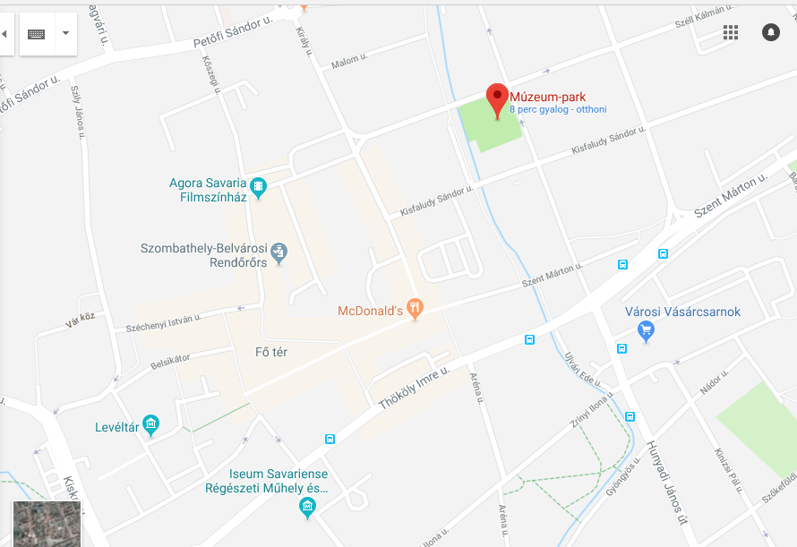

Garden of Savaria Museum

Cathedral

Bishop’s Palace

Franciscan Garden Starting Point of the Procession

Street of Wines
Rákóczi u.

