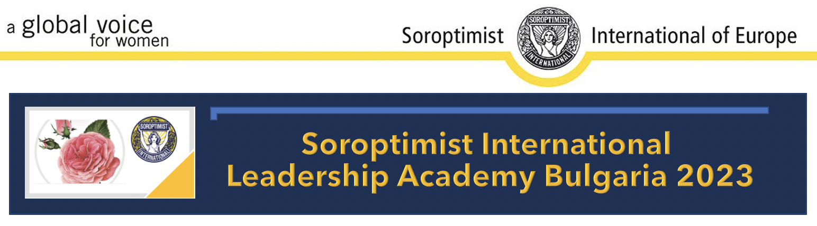

Dear Union Presidents, Single Club Presidents and Programme Directors,

Soroptimist International Bulgaria is proud to announce the

SOROPTIMIST INTERNATIONAL LEADERSHIP ACADEMY 2023

with a focus on

SOCIAL ENTREPRENEURSHIP

This innovative approach involves three hybrid phases:

Phase 1
The selection process will be conducted online through questionnaires filled by the candidates and a final interview that will provide feedback and focus on motivation.

Phase 2
During the 7-day face-to-face Boot Camp sessions the young participants (aged 24-30) will build some soft skills that are a prerequisite for success like communication, teamwork, commitment while developing projects under the skillful guidance of the LA trainers. They will become aware of their strengths and learn how to apply them both in their professions and in their social involvement and initiatives. In parallel, they will also become acquainted with the mission, vision and principles of Soroptimist through meetings and discussions with Bulgarian and European Soroptimists that excel in their professions and inspire with their dedication.

Phase 3
A follow-up 12-month online mentoring of the best projects selected at the end of Phase 2 will ensure the building of a community of people that support one another. This Mentoring Acceleration Program will establish strong relationship with the team members and guarantee the sustainability of the SLA outcomes.
We would appreciate it if you could bring to the attention of your young ambitious and proactive women either nonmembers or associated with your clubs and inspire them to participate in an unforgettable learning experience. They will have the chance to widen their horizon and create a network of friends and partners to improve the life of women and pave the road to equality through social entrepreneurship.

The event is planned for the LAST WEEK OF JUNE 2023 in the beautiful Pirin mountain in Bulgaria (26th’ June – 2nd’ July 2023)

Application forms to be sent by the end of March 2023

The language of the Soroptimist International Leadership Academy Bulgaria 2023 is English.
Participants’ travel costs to Bulgaria are to be covered by the corresponding club or Union appointed candidates to the Soroptimist International Leadership Academy Bulgaria 2023.
Transport from Sofia to the place of the event is organized and information will be communicated to the approved candidates

Registration fee per participant – 80 EUR

SI Bulgaria IPP LA coordinator
Ani Chakarova Rosina Makedonska
achakarova@adlbg.com rosina.makedonska@gmail.com
SI BULGARIA
office@soroptimistbulgaria.org
www.soroptimistbulgaria.org

Thank you for your support!

